**1)**

# index.html

<!DOCTYPE html>

<html lang="en">

<head>

    <title>String Reversal</title>

    <script src="script.js" defer></script> <!-- Link to the external JS file -->

</head>

<body>

<h1>String Reversal</h1>

<label for="inputString">Enter a string:</label>

<input type="text" id="inputString" required><br><br>

<button onclick="reverseInputString()">Reverse String</button>

<h2>Reversed String:</h2>

<p id="result"></p>

</body>

</html>

# script.js

# function reverseString(str) {

# // empty string

# let newString = "";

# for (let i = str.length - 1; i >= 0; i--) {

# newString += str[i];

# }

# return newString;

# }

# function reverseInputString() {

# // Get the input string from the user

# const string = document.getElementById("inputString").value;

# // Call the reverse function

# const result = reverseString(string);

# // Display the result

# document.getElementById("result").innerHTML = result;

# }

# OUTPUT:

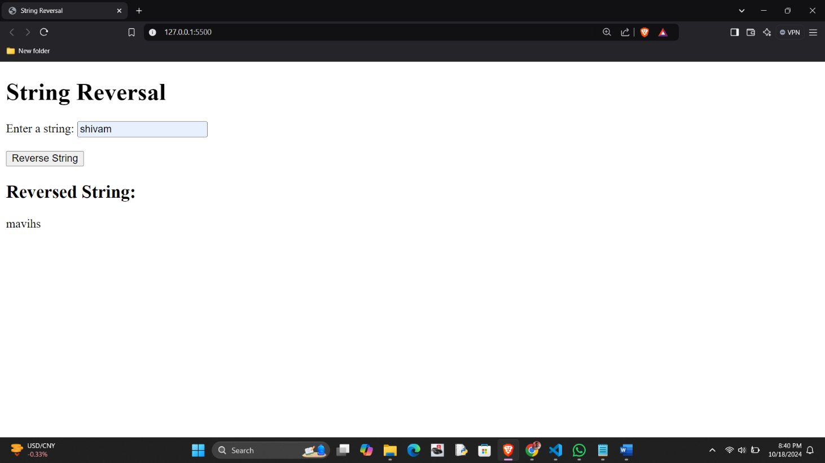

**2)**

# index.html

<!DOCTYPE html>

<html lang="en">

<head>

<title>Reverse String</title>

<script src="script.js" defer></script>

</head>

<body>

<h2>Reverse a String</h2>

<label for="inputString">Enter a string: </label>

<input type="text" id="inputString" placeholder="Enter text here">

<button onclick="reverseString()">Reverse</button>

<h3>Reversed String:</h3>

<p id="result"></p>

</body>

</html>

# Script.js

function reverseString() {

const input = document.getElementById('inputString').value; const lengthOfString = input.length;

console.log('Length of the string:', lengthOfString); let reversedString = '';

for (let i = lengthOfString - 1; i >= 0; i--) { reversedString += input[i];

}

document.getElementById('result').textContent = reversedString;

}

**3)**

# index.html

<!DOCTYPE html>

<html lang="en">

<head>

    <meta charset="UTF-8">

    <meta name="viewport" content="width=device-width, initial-scale=1.0">

    <title>String Character Replacement</title>

    <script src="script.js" defer></script> <!-- Link to the external JS file -->

</head>

<body>

<h1>String Character Replacement</h1>

<button onclick="replaceCharacter()">Replace Character</button>

</body>

</html>

# script.js

# function replaceCharacter() {

# // Original string

# const originalString = 'Mr Red has a red house and a red car';

# // Use prompt to get the character to replace and the new character from the user

# const charToReplace = prompt("Enter the character you want to replace:", "red");

# const newChar = prompt("Enter the new character:", "blue");

# // Replace the character

# const newText = originalString.replace(charToReplace, newChar);

# // Log the result to the console

# console.log("Original String: " + originalString);

# console.log("Modified String: " + newText);

# }

# // Call the function

# replaceCharacter();

# OUTPUT:

# A screenshot of a computer Description automatically generatedOUTPUT: